Lesson 4– Using Subqueries to Solve Queries

Before starting ask the question

è Give me a list of all employees that earn more than Abel

Will come back to what is the SQL logic?

OBJECTIVES

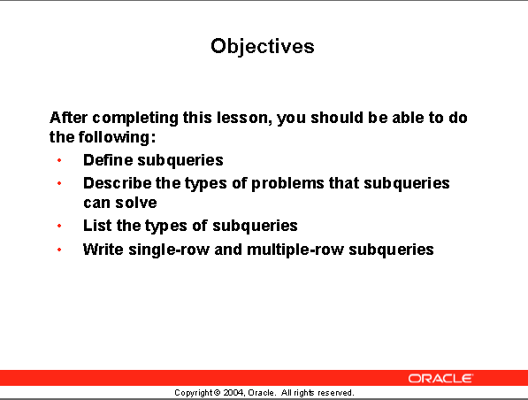

After completing this lesson, you should be able to do the following:

à Define subqueries

à Describe the type of problems that subqueries can solve

à List the types of subqueries

à Write single-row and multiple- row subqueries

This chapter covers the more advanced features of the SELECT statement.

You can write Subqueries in the where clause of another SQL statement to obtain values based on an unknown conditional value.

This chapter covers single row subqueries and multiple row subqueries.

7-4

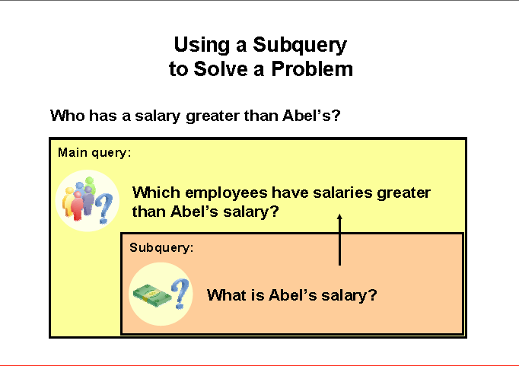

# Using a Subquery to solve a problem

## Problem:

**Who has a salary greater than Abel’s salary?**

## Solution:

**2 steps**

à Find out how much Abel earns

à Find out who earns more than that amount

That requires two queries. We need to pass information from the first query into the second query.

Writing two separate queries does not do that.

We need a Subquery to define Abel’s salary and pass it to the main query that produces the results.

7-5 (279)

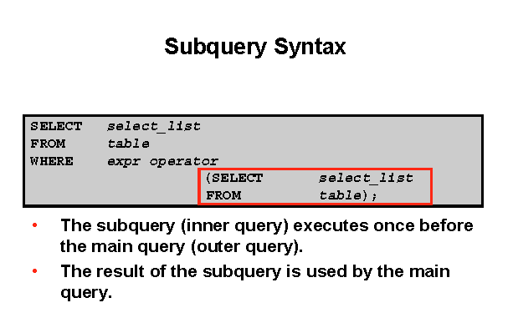

# Subquery Syntax

A Subquery is a SELECT statement that is imbedded in a clause of another SELECT statement.

Useful when you need to select rows from a table with a condition that depend so on data from the same table or other tables.

## Where used

On the following clauses:

à WHERE clause

à HAVING clause

à FROM clause

**NOTE:** operator means

Single-row operator < > = etc.

Multiple-row operators IN, ANY, ALL, EXISTS

**OTHER TERMS USED**

Nested SELECT

Sub-SELECT

Inner SELECT

**ORDER of OPERATION**

The Subquery generally executes first, and its output is then the fed to the main or OUTER query.

Using a subquery

7-6

**SELECT last_name, salary**

**FROM employees**



**WHERE salary > (SELECT salary**



**FROM employees**

**WHERE last_name = 'Abel');**

RESULT:

LAST_NAME SALARY

------------------------- ----------

King 24000

Kochhar 17000

De Haan 17000

Hartstein 13000

Higgins 12000

The above slide shows how we solve the problem of who earns more money than Abel.

Note that the Subquery executes first and returns the value 11,000.

The outer or main query then executes with the 11,000.

It will supply all employees with a salary greater than 11,000.

Suggestion: è … use an ORDER BY

7-7

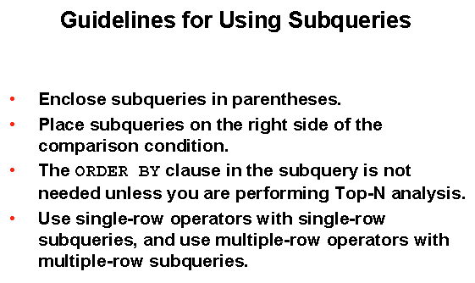

**Guidelines for using Subqueries:**

à A Subquery must be enclosed in parenthesis.

à Place the Subquery on the right side of the comparison operator for readability

You can do it the other way

***SELECT * from employees***

***WHERE (select salary from employees where last_name = 'Abel') < salary***

à ORDER BY clause in the Subquery is only needed when performing TOP-N analysis

- Normally the order by clause is only found at the end of the SQL statement.

- TOP-N analysis refers two finding the top number of rows.

- Example top seven salaries

à 2 types of Subqueries are used:

Single-row operators

Multiple-row operators

7-8

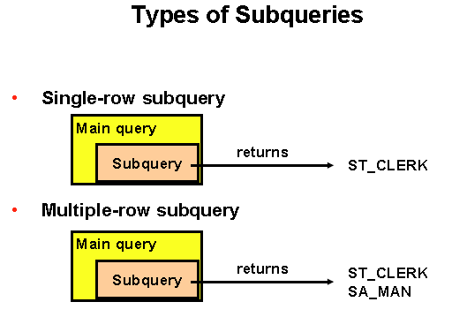

**Types of Subqueries**:

This slide shows the two types of Subqueries.

- Single-row Subqueries that return only one row from the inner SELECT statement

- in the previous question it returned 11,000 the amount of Abel’s salary

- Multiple-row Subqueries return more than one row from the inner SELECT statement

**Special note:**

**There are Subqueries that return multiple columns. These are covered later.**

6-8

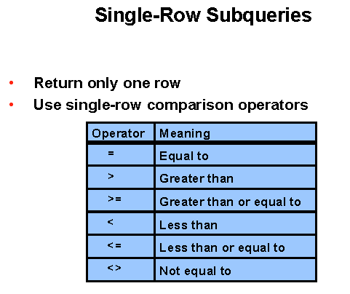

Just like other programming languages, the same operators exist

**Single-Row Subqueries**:

For single row Subqueries that return only one row from the inner SELECT statement, single row operators are used.

NOTE: Common Error:

You cannot use an equal to operator when you are comparing something to multiple rows.

**PROBLEM:**

Display the employees whose job title is the same as that of employee 8

**SOLUTION:**

1. First find the job title for employee 8

**SELECT job_title**

**FROM employees**

**WHERE employee_id = 8;**

1. Use that job title in the where clause of main to find the employees with the same title

**WRITE THE CODE TO DO THIS SOLUTION**

Demonstrate by writing INNER query first

**SELECT last_name, job_title**

**FROM employees**

**WHERE job_title = (SELECT job_title**

**FROM employees**

**WHERE employee_id = 8);**

Note: I often write the inner or Subquery first to find what it returns, then I write the main query.

**INNER QUERY**

JOB_TITLE

-----------------------------------

Programmer

**FULL RESULT**

LAST_NAME JOB_TITLE

--------------- -----------------------------------

Richardson Programmer

Cox Programmer

Torres Programmer

Ward Programmer

Howard Programmer

7-11

**Executing Single Row Subqueries**

**SELECT last_name, job_title, salary**

**FROM employees**

**WHERE job_title = (SELECT job_title**

Many subqueries can be used

**FROM employees**

**WHERE employee_id = 8)**

**AND salary > (SELECT salary**

**FROM employees**

**WHERE employee_id = 47)**

**;**

**What is this doing?**

Showing all employees that have the same job_title as employee 8

AND al salary greater than employee 47

**TEST OUT THE RESULT???**

**QUERY BLOCKS**

A SELECT statement is often called a query block.

à In the above example there are 3 query blocks.

The inner query block executes first bringing back the results **Programmer**

The other inner query block returns salary **9300**

The outer query block is then processed as if the WHERE clause was hard coded with those values that were returned from the inner query.

**NOTE:**

The Subquery can get information from different tables.

7-12

Using Group Functions in a Subquery

**PROBLEM:**

Display the last name, job title, and salary

of all employees whose salary is equal to the minimum salary of all employees.

**SOLUTION:**

To solve this problem

First get the minimum salary of all employees from the inner SELECT or subquery.

Secondly, use the result in the main query

à The inner query will result in a minimum salary of **800.**

à The 800 replaces the right side of the WHERE clause

7-12

**SELECT LAST_NAME, JOB_ID, SALARY**

**FROM EMPLOYEES**

**WHERE SALARY = (SELECT MIN (SALARY)**

**FROM EMPLOYEES);**

**Group functions in a Subquery**:

This example demonstrates that you can get information from the Subquery when the Subquery has a group function in it.

**SPECIAL NOTE:**

**The following looks correct**

SELECT LAST_NAME, JOB_TITLE, SALARY

FROM EMPLOYEES

WHERE SALARY = MIN (SALARY); ç can’t use group function here

**SELECT LAST_NAME, JOB_ID, SALARY**

**FROM EMPLOYEES**

**WHERE SALARY = (SELECT MIN (SALARY)**

**FROM EMPLOYEES);**

7-13

**PROBLEM 1:**

Display all the departments WITH minimum salary greater DEPARTMENT 50s minimum salary

Switch to previous data

Another way of saying it

Looking for all minimum salaries in each department that is greater than the minimum in department 50

Display all the departments WITH minimum salary greater than DEPARTMENT 50s minimum salary

**Step 1 –** Find the minimum salary of department 50

- that will require a group function

MIN(SALARY)

-----------

2500

**SELECT min(salary)**

**FROM employees**

**WHERE department_id = 50**;

**Step 2**-Since you want to find the minimum salary in other departments you need the group function in the main query.

**SELECT department_id, min(salary)**

**FROM employees**

**GROUP BY department_id**

Step 3-But you want to limit which groups are displayed. That requires a HAVING statement

Therefore, the inner query is attached to the HAVING statement.

**SOLUTION**

**SELECT department_id, min(salary)**

**FROM employees**

**GROUP BY department_id**

**HAVING min(salary) > ( SELECT min(salary)**

**FROM employees**

**WHERE department_id = 50);**

DEPARTMENT_ID MIN(SALARY)

------------- -----------

10 4400

Added in an ORDER BY

20 6000

60 4200

80 8600

90 17000

110 8300

7000

7 rows selected

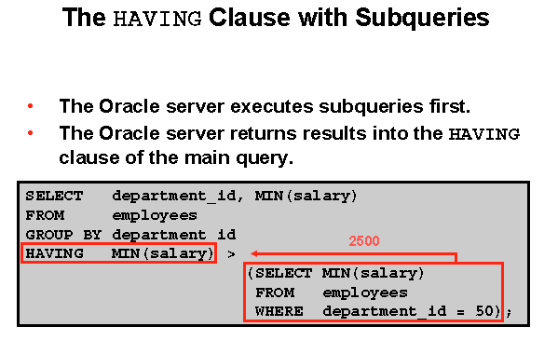

**Using Subqueries with the HAVING clause**

**PROBLEM 2:**

Find the job with the lowest average salary. Display the job title and that average salary.

**SOLUTION: #1** Find the lowest average salary for a job title

#2 Display that job title and that average salary

**SELECT job_title, AVG (salary)**

**FROM employees**

**GROUP BY job_title**

**HAVING AVG (salary) = (SELECT MIN ( AVG (salary) )**

**FROM employees**

**GROUP BY job_title );**

JOB_TITLE AVG(SALARY)

----------------------------------- -----------

Sales Representative 1133.33333 🡸 of course this needs to be rounded

What if, there are 2 job titles with the same average salary?

7-14

**What is wrong with This Statement? VERY COMMON**

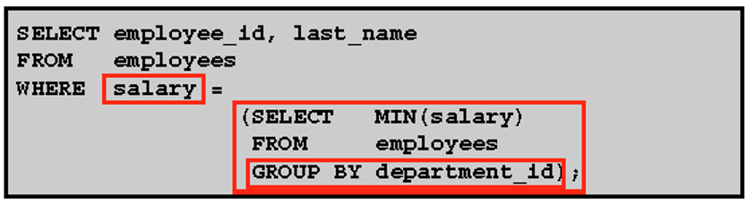



**Error:**

More than one row is returned – you cannot be equal to more than one value

When you use a GROUP BY there is an implication that there will be multiple rows returned. In this case the result of the Subquery is 7 rows returned. Each department ID in the employees table generated a minimum salary.

The outer query cannot be equal to seven different values.

# Solution:

SELECT department_id, employee_id, last_name, salary

FROM employees

WHERE salary IN (SELECT min (salary)

FROM employees

GROUP BY department_id)

*Change to IN*

DEPARTMENT_ID EMPLOYEE_ID LAST_NAME SALARY

------------- ----------- ------------------------- ----------

90 101 Kochhar 17000

90 102 De Haan 17000

60 104 Ernst 6000

60 107 Lorentz 4200

50 144 Vargas 2500

80 176 Taylor 8600

178 Grants 7000

180 de Man 7000

10 200 Whalen 4400

20 202 Fay 6000

110 206 Gietz 8300

11 rows selected

7-15

**Will this query work correctly**

SELECT last_name, job_title

FROM employees

WHERE job_title = (SELECT job_title

FROM employees

WHERE last_name = 'Haas');

**Test it out**

**COMMON PROBLEM:**

The above statement is correct. It did not return any rows from the Subquery. (no Haas exists)

The query passes a **null** value back on the WHERE clause

There is no job title that is equal to NULL.

Therefore, no rows are selected

**SPECIAL NOTE:**

If there was a job title with a NULL value then the left side value would be NULL, and the right-side value would be NULL. This means that NULL would be equal to NULL and the row would be displayed. BUT ……..

For the row to be displayed, the WHERE clause must evaluate to TRUE

Because a comparison of two NULL values results in a NULL (instead of a 1 or 0) the WHERE condition is not true

You don’t have this to try

TRY THIS ….

**select last_name, department_id,salary**

**from employees**

**where department_id = ( select department_id from employees**

**where employee_id = 178);**

Employee 178 has no department number meaning it is NULL.

**Getting a little harder …**

7-17

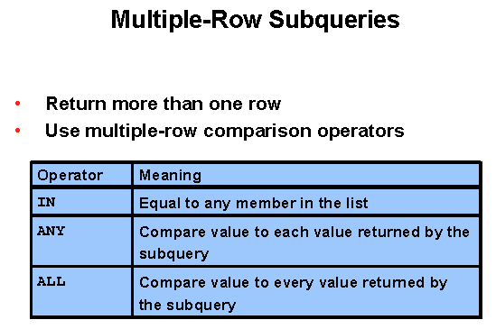

**Multiple-Row Subqueries:**

To use a Subquery that returns more than one row you need to use a Multiple-row operator

We did this before when we had a problem with the query.

We used the IN operator

SELECT department_id, employee_id, last_name, salary

FROM employees

WHERE salary IN (SELECT MIN (salary)

FROM employees

GROUP BY department_id)

DEPARTMENT_ID EMPLOYEE_ID LAST_NAME SALARY

------------- ----------- ------------------------- ----------

90 101 Kochhar 17000

90 102 De Haan 17000

60 104 Ernst 6000

60 107 Lorentz 4200

50 144 Vargas 2500

80 176 Taylor 8600

178 Grants 7000

180 de Man 7000

10 200 Whalen 4400

20 202 Fay 6000

110 206 Gietz 8300

7-18

**Problem**:

Display employees with a salary less than people with job_title of Programmer

SELECT employee_id, last_name, job_title

FROM employees

WHERE salary < ANY (SELECT salary

FROM employees

WHERE job_title = 'Programmer')

AND job_title <> 'Programmer';

**Multiple-Row Subqueries:**

**ANY clause**

Looking at the outer query, the slide displays employees who are not IT programmers

**And**

whose salary is less than ANY salary that is returned by the inner Subquery

**The inner query**

SELECT salary

FROM employees

WHERE job_title = 'Programmer'

Returns

5500 6500 7700 7800 8750

Since the outer query is looking for a salary **less than ANY** Programmer salaries then it is looking for a value that is less than 5500 and less than 6500 and less than 7700…. Etc.

In other words, it is looking for a value less than the maximum value returned by the inner Subquery. The maximum value is $8750.

This will then return all the Programmers as well, unless the final line is added to the query

**NOTE:**

**< ANY** -- less than any will mean less than the maximum return or highest one returned

**> ANY** -- greater than any means more than the minimum value returned

**= ANY** -- equal to any is the equivalent of the **IN** operator

SHOW THE IN operator

SELECT employee_id, last_name, job_title

FROM employees

WHERE salary IN (SELECT salary

FROM employees

WHERE job_title = 'Programmer');

RESULT:

EMPLOYEE_ID LAST_NAME JOB_TITLE

----------- --------------- -----------------------------------

4 Richardson Programmer

15 Kelly Purchasing Manager

5 Cox Programmer

8 Torres Programmer

105 Gardner Public Relations Representative

103 Hudson Marketing Representative

7 Ward Programmer

6 Howard Programmer

8 rows selected

With last line added

SELECT employee_id, last_name, job_title

FROM employees

WHERE salary IN (SELECT salary

FROM employees

WHERE job_title = 'Programmer')

AND job_title <> 'Programmer';

RESULT:  
EMPLOYEE_ID LAST_NAME JOB_TITLE

----------- --------------- -----------------------------------

15 Kelly Purchasing Manager

105 Gardner Public Relations Representative

103 Hudson Marketing Representative

7-19

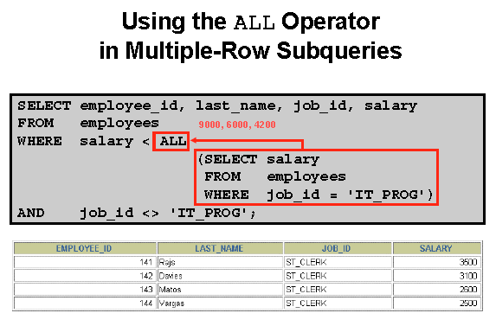

**ALL operator**

**The all operator compares a value to every value returned by a Subquery.**

The example on the slide displays employees whose salary is less than the salaries of all the employees that have a job_id of IT_PROG

AND

whose job is not the IT_PROG

Again, there are three values being returned. They are 9000, 6000 and 4200.

è To be less than ALL means you must be less than 4200

**NOTE:**

**> ALL** -- greater than all means more than the maximum

**< ALL** -- less than all means less than the minimum

**NOTE:**

The **NOT** operator can be used with any of these. Caution is recommended the use of the not operator just as it was in other programming languages.

6-17

**PROBLEM: Display employees who do not have anyone working for them. (No subordinates)**

**NULL VALUES IN A SUBQUERY**

**SELECT e.last_name**

**FROM employees e**

**where e.employee_id NOT IN**

**(SELECT mgr.manager_id** -- selecting all manager id

**FROM employees mgr)**

**;**

Passing back the list will show 107 rows.

Running the whole query gets NO ROWS

BUT using older test data

**SUBQUERY RETURNS NULL VALUES**

The subquery

SELECT mgr.manager_id

FROM employees mgr

Will return 54 rows, but one of the rows is NULL



NOTE: On next page

**NOTE: NOT IN**

**If one of the conditions is a NULL value.**

**The entire query returns no rows.**

**The problem is the NOT IN. The NOT IN is equivalent to <>ALL**

**All conditions that compare a NULL value returns a NULL**

**NOTE**: ***IN works with NULLS***

SELECT last_name

FROM employees emp

WHERE emp.employee_id IN

(SELECT mgr.manager_id

FROM employees mgr);

IN is equivalent to =ANY

**NOTE:**

*Could have added a WHERE clause in the Subquery à WHERE manager_id is NOT NULL*

SELECT last_name

FROM employees emp

WHERE emp.employee_id IN

(SELECT mgr.manager_id

FROM employees mgr);

*WHERE*  *manager_id is NOT NULL)*

**ASIDE:**

Did we need the ALIAS table names?

No, it was done for readability

**PRACTICE QUESTION**

Prompt the user for the employee last name. The query will return last name and hire date of any employee with the same job_title as the name supplied. Do not include the employee supplied.

What is the INNER query?

SELECT job_title

FROM employees

WHERE last_name = ‘&Name’; Try with Woods

Enter WOODS and it will find nothing.

Should use function UPPER on both sides

SELECT department_id

FROM employees

WHERE **UPPER(last_name) = UPPER('&Name');**

Now do the outer query

**SELECT last_name, job_title**

**FROM employees**

**WHERE job_title** = ( SELECT job_title

FROM employees

WHERE UPPER(last_name) = UPPER ('&Name'));

Now eliminate the name entered

SELECT last_name, department_id

FROM employees

WHERE department_id = ( SELECT department_id

FROM employees

WHERE UPPER(last_name) = UPPER('&&Name') )

**AND** **UPPER (last_name) < > UPPER ('&Name');**

UNDEFINE NAME;

# Multiple Column Sub Query

A multiple-column subquery returns more than one column to the outer query and can be listed in the outer query's FROM, WHERE, or HAVING clause. For example, the below query shows the employee or employees in each department whose current salary is the lowest (or minimum) salary in the department.

SELECT last_name, job_title, salary

FROM employees

WHERE (job_title, salary) IN (SELECT job_title, min(salary)

FROM employees

GROUP BY job_title)

ORDER BY job_title;

The query returns 26 rows